Experiment-6
Name: -J pranitha Regno: -192472073
Course Code: -MLA0305 Slot-B

Title Implementation of Monte Carlo Prediction and Control for Reinforcement Learning Aim
To implement Monte Carlo Prediction and Monte Carlo Control methods for Reinforcement Learning, estimate the value function from complete episodes, and learn an optimal policy using an ε-greedy strategy.

Procedure
- Define a simple Reinforcement Learning environment with a finite set of states and actions.
- Define the reward function and terminal state.
- Select the discount factor and number of training episodes.
- Generate complete episodes by allowing the agent to interact with the environment.
- Calculate the return by processing the rewards obtained during an episode.
- Implement First-Visit Monte Carlo Prediction:
  - Identify the first occurrence of each state. _{o} Calculate
its return.
  - Update the estimated state value .
- Implement Monte Carlo Control using an ε-greedy policy.
- Initialize the action-value function .
- Generate episodes using exploration and exploitation.
- Calculate the return for each state-action pair.
- Update using the observed returns.
- Improve the policy by selecting the action with the maximum Q-value:
𝜋(𝑠) = 𝑎𝑟𝑔𝑎𝑚𝑎𝑥𝑄(𝑠, 𝑎) 13.
Repeat the process for the specified number of episodes.
- Calculate the optimal policy from the learned Q-values.
- Evaluate the performance using reward, return, success rate, and episode length.
- Generate graphs showing value convergence, reward, Q-values, and exploration vs exploitation.
- Display summary tables and export the results to CSV files.
Important Equations Monte Carlo Return
𝐺𝑡 = 𝑅𝑡 + 1 + 𝛾𝑅𝑡 + 2 + 𝛾2𝑅𝑡 + 3 + ⋯
State Value
𝑉(𝑠) = 𝐴𝑣𝑒𝑟𝑎𝑔𝑒 𝑜𝑓 𝑟𝑒𝑡𝑢𝑟𝑛𝑠 𝑜𝑏𝑠𝑒𝑟𝑣𝑒𝑑 𝑎𝑓𝑡𝑒𝑟 𝑣𝑖𝑠𝑖𝑡𝑖𝑛𝑔 𝑠
Action Value
𝑄(𝑠, 𝑎) = 𝐴𝑣𝑒𝑟𝑎𝑔𝑒 𝑜𝑓 𝑟𝑒𝑡𝑢𝑟𝑛𝑠 𝑜𝑏𝑠𝑒𝑟𝑣𝑒𝑑 𝑎𝑓𝑡𝑒𝑟 𝑡𝑎𝑘𝑖𝑛𝑔 𝑎 𝑖𝑛 𝑠

Optimal Policy
𝜋 ∗ (𝑠) = 𝑎𝑟𝑔𝑎𝑚𝑎𝑥𝑄(𝑠, 𝑎)
Code import numpy as np import pandas as pd import matplotlib.pyplot as plt
import random import time print("=" * 75)
print("EXPERIMENT 6") print("MONTE CARLO PREDICTION AND CONTROL")
print("=" * 75) print("\nAIM")
print("-" * 75)
print("To implement Monte Carlo Prediction and Monte Carlo Control") print("for estimating state values and learning an optimal policy") print("in a Reinforcement Learning environment.") print("\nTHEORY")
print("-" * 75) print("Monte Carlo methods learn from complete episodes.") print("Monte Carlo Prediction estimates the value of states.") print("Monte Carlo Control learns an optimal policy.") print("The return is calculated from the rewards obtained") print("after visiting a state.")
print("\nReturn Formula:") print("G(t) = R(t+1) + gamma*R(t+2) + gamma^2*R(t+3) + ...")
states = ["Start", "S1", "S2", "S3", "Goal"] actions = ["Left", "Right"] n_states = len(states) n_actions = len(actions)
gamma = 0.90
alpha = 0.10 epsilon = 0.20 episodes = 1000 max_steps = 20
def get_next_state(state, action): if state == 0: if action == 0: return 0, -1 else:
return 1, 0 elif state == 1: if action == 0: return 0, -1 else:
return 2, 0 elif state == 2: if action == 0: return 1, -1 else:
return 3, 0 elif state == 3: if action == 0: return 2, -1
else:
return 4, 10 else:
return 4, 0
def generate_episode(policy=None, q_table=None):
episode = [] state = 0
for step in range(max_steps): if q_table is not None: if random.random() < epsilon:
action = random.randint(0, n_actions - 1)
else:
action = int(np.argmax(q_table[state])) elif policy is not None: action = policy[state]
else:
action = random.randint(0, n_actions - 1) next_state, reward = get_next_state(state, action) episode.append((state, action, reward))
state = next_state if state == 4: break
return episode print("\n") print("=" * 75)
print("MONTE CARLO PREDICTION")
print("=" * 75) prediction_start = time.time()
V_prediction = np.zeros(n_states)
returns_sum = {state: 0.0 for state in range(n_states)} returns_count = {state: 0 for state in range(n_states)} prediction_rewards = [] prediction_returns = [] prediction_value_history = [] prediction_policy = np.zeros(n_states, dtype=int) prediction_policy[-1] = 1 for episode_number in range(episodes):
episode = generate_episode(policy=prediction_policy)
G = 0 visited_states = set() total_reward = 0 for t in range(len(episode) - 1, -1, -1): state, action, reward = episode[t] G = gamma * G + reward total_reward += reward
if state not in visited_states: visited_states.add(state) returns_sum[state] += G returns_count[state] += 1 V_prediction[state] = ( returns_sum[state] / returns_count[state]
)
prediction_rewards.append(total_reward) prediction_returns.append(G) prediction_value_history.append(V_prediction.copy()) prediction_time = time.time() - prediction_start print("Monte Carlo Prediction Completed.") print("Episodes :", episodes)
print("Execution Time :", round(prediction_time, 5), "seconds") prediction_table = pd.DataFrame({
"State": states,
"Estimated Value": np.round(
V_prediction, 3
),
"Visits": [ returns_count[i] for i in range(n_states)
]
})
print("\nMonte Carlo Prediction Results") print("-" * 75) print(prediction_table) prediction_table.to_csv( "MonteCarlo_Prediction.csv", index=False
)
print("\n") print("=" * 75)
print("MONTE CARLO CONTROL")
print("=" * 75) control_start = time.time()
Q = np.zeros((n_states, n_actions))
Q_returns_sum = np.zeros((n_states, n_actions)) Q_returns_count = np.zeros((n_states, n_actions)) control_policy = np.zeros(n_states, dtype=int) control_policy[-1] = 0 control_rewards = [] control_returns = []
Q[:, 0], 3
),
"Right Q-Value": np.round(
Q[:, 1], 3
),
"Optimal Action": optimal_policy
})
print("\n") print("=" * 75)
print("OPTIMAL POLICY")
print("=" * 75) print(policy_table) policy_table.to_csv( "MonteCarlo_Control.csv", index=False
)
q_table.to_csv(
"MonteCarlo_Q_Table.csv"
)
print("\n") print("=" * 75)
print("EXPLORATION VS EXPLOITATION")
print("=" * 75) print( "Exploration Count :", exploration_count
)
print(
"Exploitation Count :", exploitation_count
)
total_decisions = ( exploration_count + exploitation_count
)
exploration_percentage = ( exploration_count / total_decisions * 100
)
exploitation_percentage = ( exploitation_count / total_decisions * 100
)
print(
"Exploration Percentage :", round(exploration_percentage, 2),
"%"
)
print(
"Exploitation Percentage :", round(exploitation_percentage, 2),
"%"
)
prediction_value_history = np.array( prediction_value_history
)
q_value_history = np.array( q_value_history
)
policy_history = np.array( policy_history
)
plt.figure(figsize=(10, 5)) plt.plot( prediction_rewards, color="royalblue", linewidth=1.5
) plt.title(
"Monte Carlo Prediction - Reward vs Episode", fontsize=14
)
plt.xlabel("Episode") plt.ylabel("Total Reward") plt.grid(True, alpha=0.3) plt.show() plt.figure(figsize=(10, 5)) for i in range(n_states):
plt.plot( prediction_value_history[:, i], linewidth=2, label=states[i]
)
plt.title(
"Monte Carlo Prediction - State Value Convergence", fontsize=14
)
plt.xlabel("Episode") plt.ylabel("Estimated State Value") plt.legend()
[
exploration_count, exploitation_count
],
labels=[
"Exploration",
"Exploitation"
],
autopct="%1.1f%%",
startangle=90, colors=[
"gold",
"lightgreen"
],
explode=[
0.05,
0
] ) plt.title(
"Exploration vs Exploitation Percentage", fontsize=14
)
plt.show() plt.figure(figsize=(10, 5)) plt.plot( control_steps,
color="mediumorchid", linewidth=1.5
)
plt.title(
"Episode Length During Monte Carlo Control", fontsize=14
)
plt.xlabel("Episode") plt.ylabel("Number of Steps") plt.grid(True, alpha=0.3) plt.show() success_rate_history = [] for i in range(1, len(success_history) + 1): success_rate_history.append( np.mean(success_history[:i]) * 100
)
plt.figure(figsize=(10, 5)) plt.plot( success_rate_history, color="crimson", linewidth=2.5
) plt.title(
"Monte Carlo Control - Success Rate", fontsize=14
)
plt.xlabel("Episode") plt.ylabel("Success Rate (%)") plt.ylim(0, 105) plt.grid(True, alpha=0.3) plt.show() prediction_average_reward = np.mean( prediction_rewards
)
prediction_average_return = np.mean(
prediction_returns
)
control_average_reward = np.mean(
control_rewards
)
control_average_return = np.mean(
control_returns
)
control_success_rate = ( np.mean(success_history) * 100
)
average_episode_length = np.mean(
control_steps
)
maximum_q_value = np.max(Q) average_q_value = np.mean(Q) final_prediction_value = np.mean(
V_prediction
)
prediction_summary = pd.DataFrame({
"Metric": [
"Number of Episodes",
"Average Reward",
"Average Return",
"Average State Value",
"Maximum State Value",
"Execution Time (seconds)"
],
"Value": [ episodes,
round(prediction_average_reward, 3), round(prediction_average_return, 3), round(final_prediction_value, 3), round(np.max(V_prediction), 3), round(prediction_time, 5)
]
})
print("\n") print("=" * 75)
print("MONTE CARLO PREDICTION SUMMARY")
print("=" * 75) print(prediction_summary.to_string(index=False)) control_summary = pd.DataFrame({
"Metric": [
"Number of Episodes",
"Average Reward",
"Average Return",
"Success Rate (%)",
"Average Episode Length",
"Average Q-Value",
"Maximum Q-Value",
"Execution Time (seconds)"
],
"Value": [ episodes,
round(control_average_reward, 3), round(control_average_return, 3), round(control_success_rate, 2), round(average_episode_length, 2), round(average_q_value, 3), round(maximum_q_value, 3), round(control_time, 5)
]
})
print("\n") print("=" * 75)
print("MONTE CARLO CONTROL SUMMARY")
print("=" * 75) print(control_summary.to_string(index=False)) comparison = pd.DataFrame({
"Metric": [
"Average Reward",
"Average Return",
"Execution Time (seconds)"
],
"Monte Carlo Prediction": [ round(prediction_average_reward, 3), round(prediction_average_return, 3), round(prediction_time, 5)
],
"Monte Carlo Control": [ round(control_average_reward, 3), round(control_average_return, 3), round(control_time, 5)
]
})
print("\n") print("=" * 75) print("PREDICTION VS CONTROL COMPARISON")
print("=" * 75) print(comparison.to_string(index=False)) optimal_policy_table = pd.DataFrame({
"State": states,
"Left Q-Value": np.round(
Q[:, 0], 3
),
"Right Q-Value": np.round(
Q[:, 1], 3
),
"Optimal Action": optimal_policy
})
print("\n") print("=" * 75)
print("FINAL OPTIMAL POLICY")
print("=" * 75) print( optimal_policy_table.to_string( index=False
)
)
exploration_table = pd.DataFrame({
"Strategy": [
"Exploration",
"Exploitation"
],
"Count": [ exploration_count, exploitation_count ],
"Percentage": [
round( exploration_percentage,
2
),
round( exploitation_percentage,
2
)
]
})
print("\n") print("=" * 75)
print("EXPLORATION VS EXPLOITATION SUMMARY")
print("=" * 75) print( exploration_table.to_string( index=False
)
)
prediction_summary.to_csv( "MonteCarlo_Prediction_Summary.csv",
index=False
)
control_summary.to_csv( "MonteCarlo_Control_Summary.csv",
index=False
)
comparison.to_csv(
"Prediction_vs_Control.csv", index=False
)
optimal_policy_table.to_csv( "MonteCarlo_Optimal_Policy.csv", index=False
)
exploration_table.to_csv( "Exploration_vs_Exploitation.csv", index=False
)
combined_summary = pd.DataFrame({
"Algorithm": [
"Monte Carlo Prediction",
"Monte Carlo Control"
],
"Average Reward": [
round( prediction_average_reward,
3
),
round( control_average_reward,
3
)
],
"Average Return": [
round( prediction_average_return,
3
),
round( control_average_return,
3
)
],
"Execution Time": [
round( prediction_time,
5
),
round( control_time,
5
)
],
"Episodes": [ episodes, episodes
]
})
print("\n") print("=" * 75)
print("FINAL COMBINED SUMMARY")
print("=" * 75) print( combined_summary.to_string(
index=False
)
)
combined_summary.to_csv( "MonteCarlo_Final_Summary.csv", index=False
)
plt.figure(figsize=(9, 5)) plt.bar(
["Prediction", "Control"],
[
prediction_average_reward, control_average_reward
],
color=[
"cornflowerblue",
"lightgreen"
] ) plt.title(
"Monte Carlo Prediction vs Control - Average Reward", fontsize=14
)
plt.xlabel("Method") plt.ylabel("Average Reward")
plt.grid( axis="y", alpha=0.3
)
plt.show() print("\n") print("=" * 75)
print("FINAL RESULT")
print("=" * 75) print(
"Monte Carlo Prediction estimated the value of states"
)
print(
"using returns collected from complete episodes."
)
print(
"Monte Carlo Control learned action values and"
)
print(
"improved the policy using an epsilon-greedy strategy."
)
print(
"The learned optimal policy is:"
)
for state, action in zip(
states,
optimal_policy
):
print( f"{state} --> {action}"
)
print("\n") print("=" * 75)
print("CONCLUSION")
print("=" * 75) print(
"Monte Carlo Prediction and Control were successfully"
)
print(
"implemented for a Reinforcement Learning environment."
)
print(
"Monte Carlo Prediction estimated the state-value function"
)
print(
"from complete episodes without requiring a model of"
)
print(
"the environment."
)
print(
"Monte Carlo Control estimated Q-values and improved the"
)
print(
"policy using exploration and exploitation."
)
print(
"The learned policy guides the agent toward the Goal state."
)
print("\n") print("=" * 75)
print("FILES GENERATED")
print("=" * 75)

Visualizations
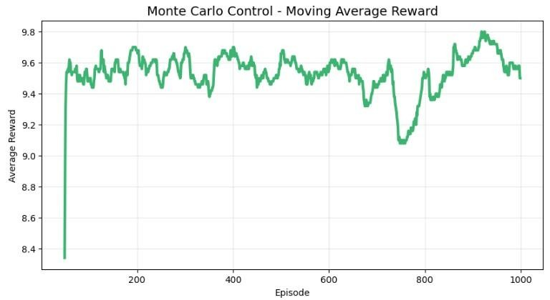
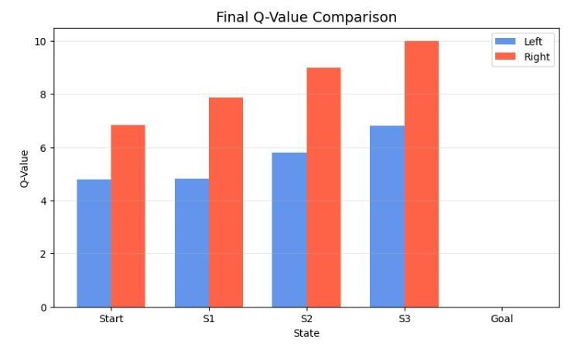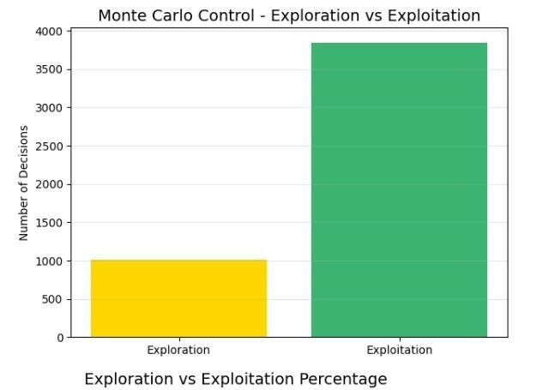
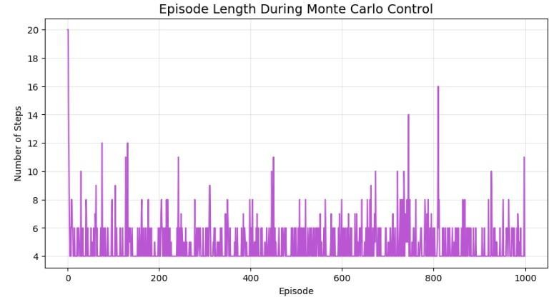
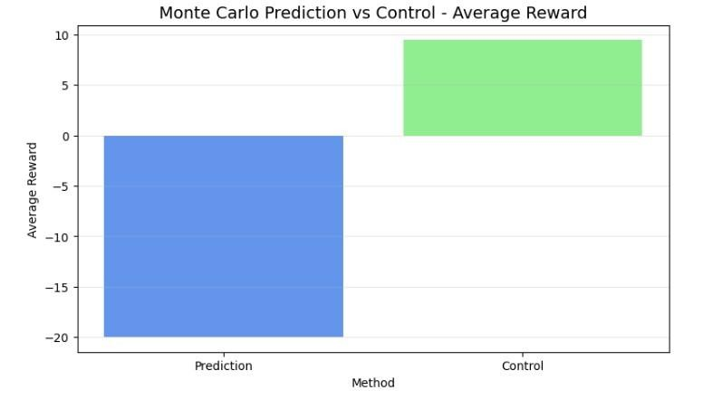

Summary Table – Monte Carlo Prediction
State | Estimated Value | Number of Visits
Start | Obtained from program | Obtained
S1 | Obtained from program | Obtained
S2 | Obtained from program | Obtained
S3 | Obtained from program | Obtained
Goal | Obtained from program | Obtained

Summary Table – Monte Carlo Control
State | Left Q-Value | Right Q-Value | Optimal Action
Start | Obtained | Obtained | Obtained
S1 | Obtained | Obtained | Obtained
S2 | Obtained | Obtained | Obtained
S3 | Obtained | Obtained | Obtained
Goal | Obtained | Obtained | Terminal

Result
Monte Carlo Prediction and Control were successfully implemented.

